

In this lesson we will learn how to make radio button in React Native. Now you will say why to make radio buttons Reach native might have their own predefined radio buttons like normal buttons o there is text input No in react native there is no predefined radio buttons If you want to use radio button in react native either you make them manually or install there npm package and then we can use later. In this lesson we will make our own manual radio buttons and do our own style and no external package will be used By this you can improve your logical part. In styling you will learn new things How you can do advanced styling and here we are going to take static radio button as shown below

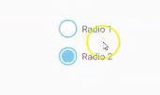

Here you will see only two buttons here. In upcoming part of the lesson we will make dynamic radio buttons. There will be an array Inside array there will be lots of values the more values we have the more radio buttons we will make and you can select only one at once here. Firstly we are making a static with only two radio buttons so that you can understand what styling to use and you will understand everything that is styling o logic part of the radio buttons and then you can make dynamic yourself if not then in next lesson Teacher will make us understand

First we will take two touchable opacity with Text whatever you see in the screen The buttons you se in the above screenshot are modified from Touchable Opacity Now you will say that the touchable highlight we earnt in previous lesson why did you not learnt it In button there are limitation in style but yes you can use Touchable highlight because but there will be lot more effort and in Touchable opacity effort will be less (who knows) So Teacher recommend that whenever you make your own check box or radio buttons then use Touchable opacity it will be better I think the effort is of writing text like Radio1 and radio 2 shown in the screenshot

And then we will apply style here and will make it properly round and apply border and its shape will look like radio button. And the we use state to add functionality of selecting and deselecting radio button. And then teacher will some interview question and these question will be covered like How to make radio buttons and they exist or not in React native but again we will again cover lots of question So we will start with our code. Our code App.js code now look like below

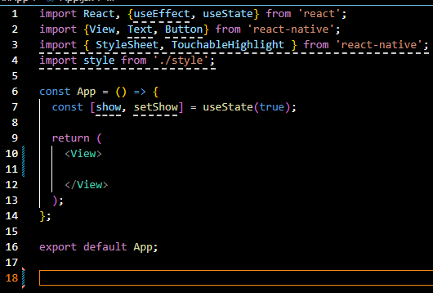

First we will do UI part that is add element there and we will add style later

So we import our TouchableOpacity in our file and we will use it in our JSX as shown below

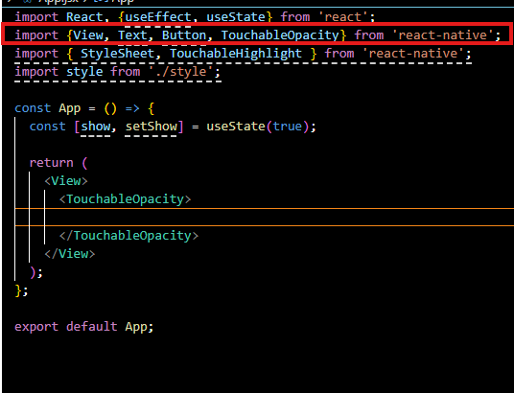

You can take a view here and inside we take text and then we write radio1 in it now our design code will look like below

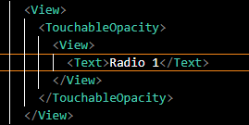

Now in output you can see that the in the output below

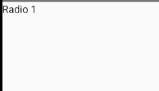

So we need to center it so we add style here. so we do internal css so we imported StyleSheet

And to use that we store it inside a const that is style we add a “main” property in it. which we will apply to the Top View. Now our code look like below

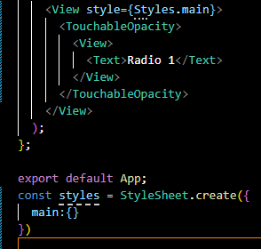

Now to make the text look perfect(who knows) we add a flex in main and then we do align item that is center. And then justify-content that is our center. Now you can see In output the the radiobutton is in the center of the screen as shown below

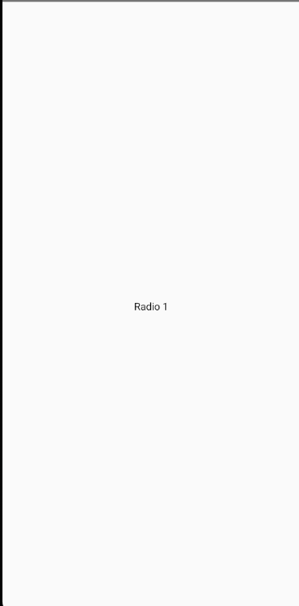

Now we apply stye on our text and name this property radioText as shown below and we give it font size of 20 as shown in styles

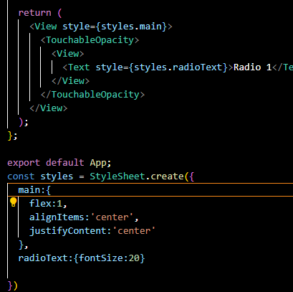

Now our output will look like below

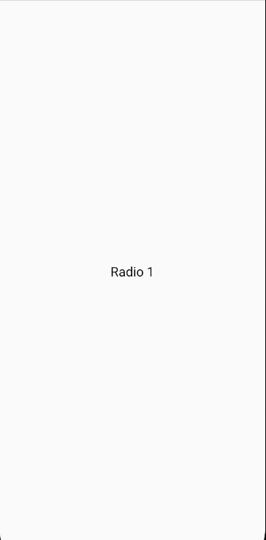

Now it is big in size and in center as shown above

5:16

Now we need a code wrapper View along with the text Component So now we take another wrapper that is View along with the Text and inside the outer View

Now our design code look like below

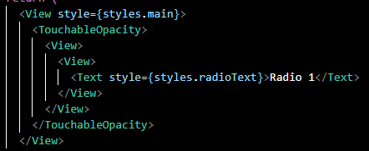

Now add a stylesheet property radio on our View wrapper around text

Now we add radio property in our stylesheet in radio property we add a height and width of 40 pixel if you want to give more than you can do so add border color black. You will know that you can change the color and by default how colors are changes (who knows). Now we add a border width here of 2px

**Design Code**

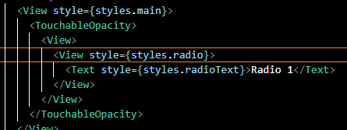

**Style code**

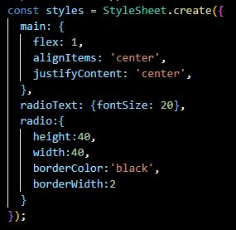

Now our output will look like below

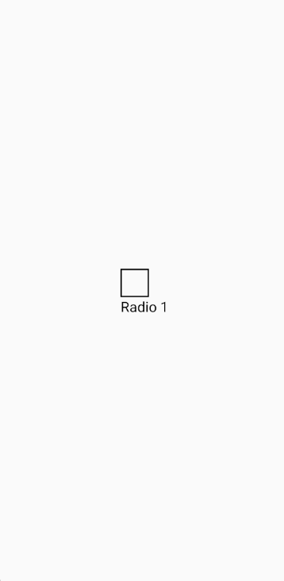

Now we add border radius(always choose radius half of width preferred by the Teacher then it will come in round shape as shown in the output below) to the radio property of style as shown below in the style code

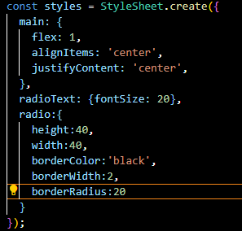

Now our output will look like below

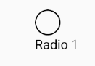

Now you can see above that the radio button is in round shape

Add margin property to radio so that if another radio is added then there will be a gap between the radio button if another is added

**Design Code**

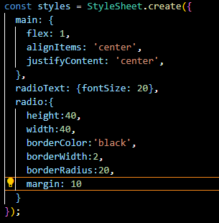

We want that that radio1 text should come in line with the radio button that is View so we add a stylesheet property radioWrapper to the outer View in the TouchableOpacity so we add radioWrapper property to the styles in which we added property that is flexDirection and give it value of row

**Design code**

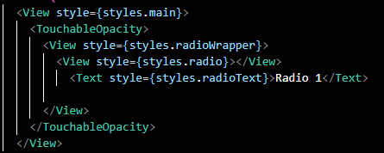

**Style code**

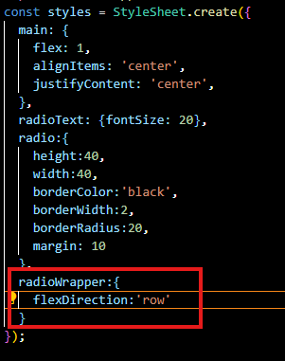

**Output**

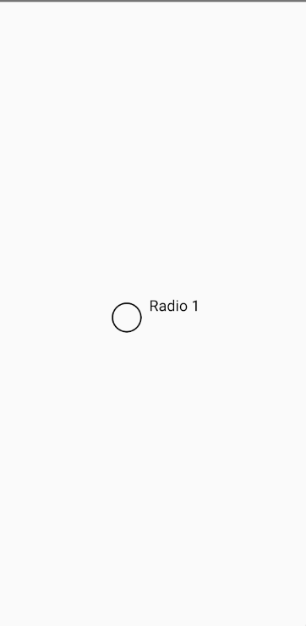

As you can see in output Now they come in one line

8:03

But it is not in center so we add property alignItems in radioWrapper property of styles.

Now our style redioWrapper property of style look like below

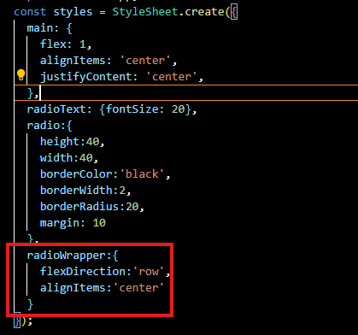

Now our output will look like below

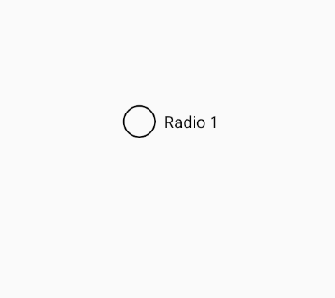

Now we can see the text in the center. Now one radio button is made clearly as shown above

Now similarly we can make another radio button So in our design code we duplicate the marked below

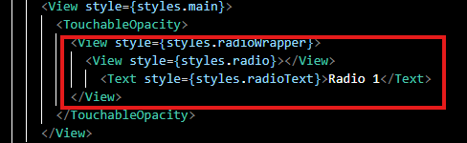

Now we replace the radio 1 with radio 2. And now our output will look like below

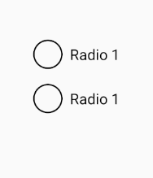

Now we cannot check it we just we can click it and we can click it then all the radio button click at once. Like they are together as shown below.



Its reason is that we have taken both of them in single Touchable Opacity. So we need to take them separately also.so we need to actually duplicate the Touchable Opacity. So after this now our design code look like below

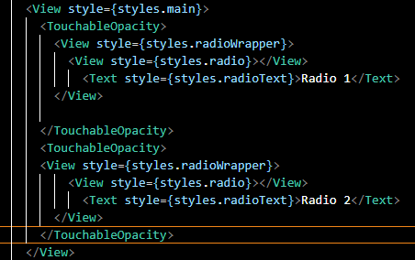

Now if you click on any one of them now both of them will not be clicked this time as shown below in the output

We are seeing it is pressed but we could not see that it is selected like there is selection tick in a normal radio button So for that we apply it in the first radio button and later we will make it dynamic (who knows) By dynamic I think Teacher mean that the check mark should come in when it is selected and it should be removed when other is selected (who knows) but for now we are using it on first So we make a View inside the view whose style is radio and we give this style of property radioBg and we add this radioBg property in styles and we give it backgroundColor of black and give it height and width of 40 equal to the radio button we give as we do it then the output look like below

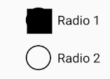

Now we give border radius in radioBg of 20 and now out look like below

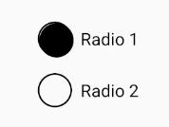

Now you can see it that it covers the whole radio button it should be slightly small then it would have been look good So first of all we need to reduce some height we give height and width of 28 instead of 40 Now you can see it in the corner as shown below

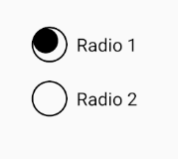

Now we will add a margin to the radioBg property of styles of 4 by this you can see below it is in the center of the radio button.

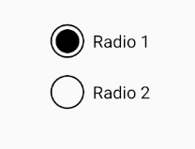

Because margin will be applied from all sides

11:20

As from all sides margin is applied you can toggle the margin you will not see any problem here.

Now you can the selection symbol only in one radio but you cannot see other one Now how to bring it in another one . So for that you need to add condition here. So we take a state here

If we want then you can do so by cutting and pasting the radioBg View to the second Radio button if you want as shown below

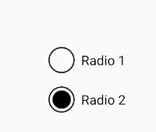

Now if you paste in both of the radio then both will be selected as shown below

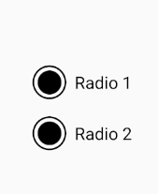

But it should be conditional so we make a state selectedRadio and then use set method setSelectedRadio to update it and set its default value as 1 as shown below

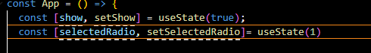

Now in our design code we add a condition for our first radio button. That is as shown below in the design code

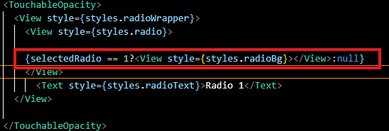

Since the value of radio button is 1 then the first radio button selected is shown below

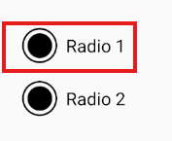

If we have made the default value of selectedRadio as 2 then first radio button will not be selected as shown below

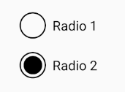

So we leave selectedRadio as 1 Now just paste the same consitional code in second radio button design code but this time selectedRadio as shown below in the design code

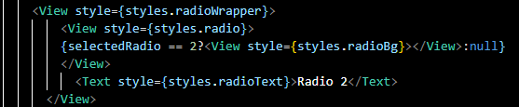

Now you can see since the selectedRadio is equal to one the first radio button is selected as shown below

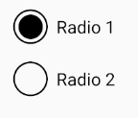

So only one can be selected at a time as selectedRadio value is one then first radio button is selected and if its value is 2 then second radio button is selected If we keep the default value 2 then second radio button will be selected as shown below

**Code:-**



**Output:-**

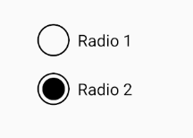

13:49

But for now we keep it one Now you need to add onPress on first radio button and in this use callback function use set method for selectedRadio and set it to 1 and do the same with second radio buttion but this time set it to 2

Now our design code look like below

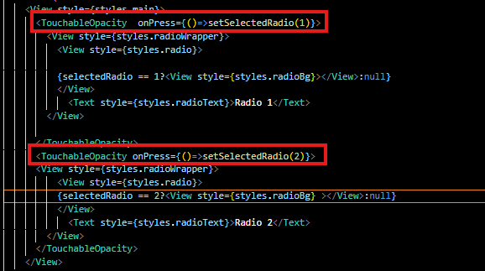

So if we click on first radio button then selectedRadio value will be equal to 1 then first radio button will be selected and if it is equal to 2 so the second radio button is selected as shown below



Now in your style you can change radio text color and modify accordingly

And you can also change color for selection I make it sky blue as shown below

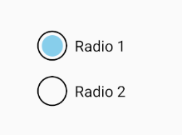

So that’s How you can make radio buttons . in next lesson we will take an array and will take many values there so whatever two static array you can see here these all will come from array with the help of map function we will create dynamically and also select them dynamically and he will show us properly and this is the exercise for us Try it yourself or if you want and try to make check box it will boost your confidence as you will implement this . Now even we can make a UI element and it will give you separate confidence (who knows) See you in the next lesson.